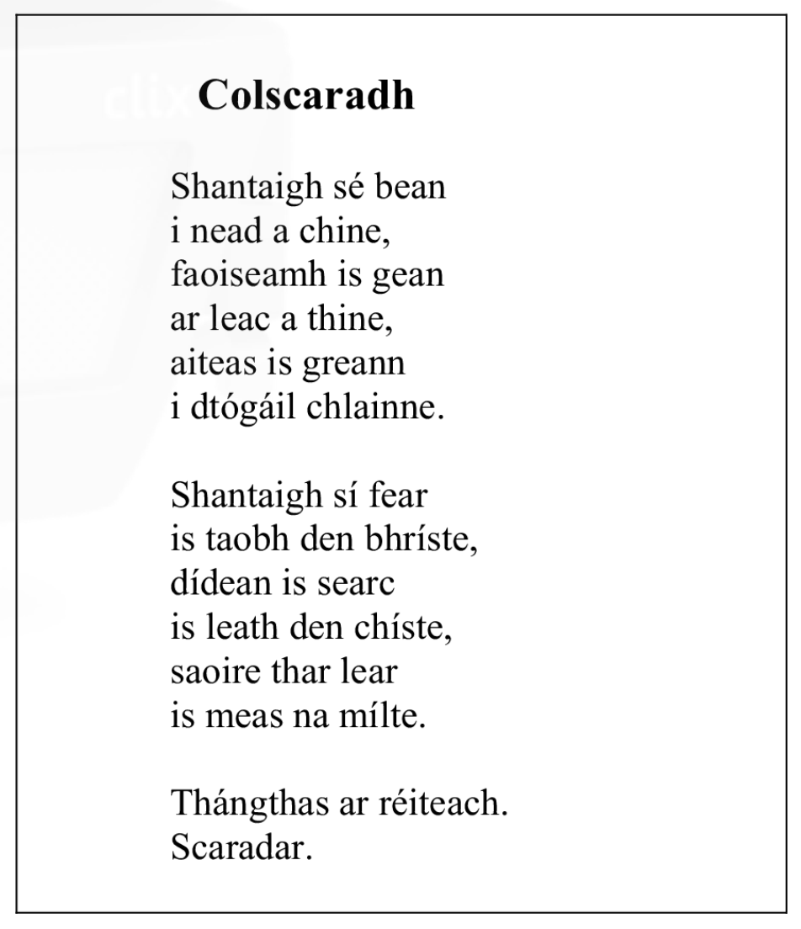

Colscaradh
An file
- Name | Scríobh Pádraig Mac Suibhne an dán seo
- Birth date | Rugadh é i gCo. Dhún na nGall, 1942
- Study | Rinne sé staidéar in ollscoil Mhaigh Nuad – céim sa Ghaeilge agus Stair
- What they did | Chaith sé tréimhse ag obair mar mhúinteoir iarbhunscoile
- Published works | D’fhoilsigh sé dhá chnuasach filíochta – ‘Solas Uaigneach’ agus ‘Spaisteoireacht’
- Now | Tá sé in a chonaí in Ard na Rátha i gContae Dhún na nGall
General
This poem concerns the relationship between married people | Baineann an dán seo le deacrachtaí caidrimh idir daoine pósta
The man wanted to have a family and a comfortable house, but the woman wanted holidays abroad and respect from others | Bhí an fear ag iarraidh go mbeadh clann agus teach compordach aige, ach bhí an bhean ag iarraidh laethanta saoire thar lear agus meas ó dhaoine eile
The simple, traditional love that the man promotes is not enough. | Ní leor an grá simplí, traidisiúnta a chuireann an fear chun cinn.
Materialistic | ábharaíoch
The trouser is a metaphore for the power | Is meafar í an bhríste den chumhacht
This poem contrasts between the man's wishes and the wishes of the woman | Tá codarsnacht sa dán seo idir mianta an fhir agus mianta na mná
There is disappointment to be felt in the last line | Tá díomá le brath sa line dheireanach
The gap between them was too wide and they had to find a solution | Bhí an bhearna eatarthu róleathan agus bhí orthu teacht ar réiteach
It is a traditional marriage that unites the man, he married to settle down | Is pósadh traidisiúnta a shantaíonn an fear, phós sé chun socrú síos
A woman's marriage is a modern marriage, where she would be on a par with her husband | Is é pósadh nua-aoiseach a shantaíonn an bhean, pósadh ina mbeadh sí ar chomhchéim lena fear chéile
Love, sadness and disappointment are the strongest emotions in this poem | Is iad grá, brón agus díomá na mothucháin is láidre sa dán seo
The poet gives us a picture of traditional marriage | Tugann an file pictiúr dúinn de phósadh traidisiúnta
In the second verse, we see a different temperament | Sa dara véarsa, feicimid meon difriúil
There is a contrast between the two perspectives | Tá codarsnacht le feiceáil idir an dá dhearcadh
There is a lack of understanding between the two | Tá easpa tuisceana le feiceáil idir an bheirt
We get a negative view of the marriage | faighimid léargas diúltach ar an bpósadh
The poem ends on a cynical note | críochnaíonn an dán ar nóta ciniciúil
The poem eventually ends suddenly | Cuirtear deireadh tobann leis an dán sa deireadh
An Fear
When the man married, he desired a settled life among his family | Nuair a phós an fear, shantaigh sé saol socraithe i measc a mhuintire
He is a traditional, old-fashioned man | Fear traidisiúnta, seanfhaiseanta isea é
He has a definite opinion - living in a native area 'in his own den', having children 'in raising a family' and his wife at home 'on a fireplace' | Tuarimí cinnte aige - ina chónaí cheantar dúchais 'i nead a chine', clann a bheith acu 'i dtógail clainne' agus a bhean sa bhaile 'ar leac a thine'
The man has all authority and power | Is ag an bhfear atá an t-údarás agus an chumacht go léir
There is only 1 reference in the first verse of love | Níl ach tagairt amháin sa chéad véarsa don ghrá (“gean”)
The essence of the problem | Croílár na faidhbe
An Bhean
The woman needs a rich man | Tá fear saibhir ag teastáil ón mbean
Personal freedom, material things | Saoirse phearsanta, rudaí ábartha
Wishes of women focused on things outside the home | Mianta na mná dírithe ar rudaí taobh amuigh den bhaile
There is no talk about family | Níl aon chaint faoi chlann
The woman desired power and authority in her life | Shantaigh an bhean cumhacht agus údarás ina saol
She wants to be on the same level as her husband | Ba mhaith léi a bheith ar chomhchéim lena fear chéile
The woman is in the background | Tá an bhean sa chúlra
She goes overboard with what she wants | Teánn sí thar fóir leis an méid atá uaithi
The poor woman has nothing | Níl faic ag an mbean bhocht
When the woman married, she desired independence in her life | Nuair a phós an bhean, shantaigh sí neamhspleáchas ina saol
There is only 1 reference of love | Níl ach tagairt amháin don ghrá (“searc”)

